CPanel Git version Control

- CPanel->Open Terminal
- Enter : [Generate a SSH key to allow connection with git]
- ssh-keygen -t rsa -b 4096

//OR//

ssh-keygen -t rsa -b 4096 -f ~/.ssh/id_rsa_cpanel

[when asked for PassKey or PassPhrase Click Enter ]

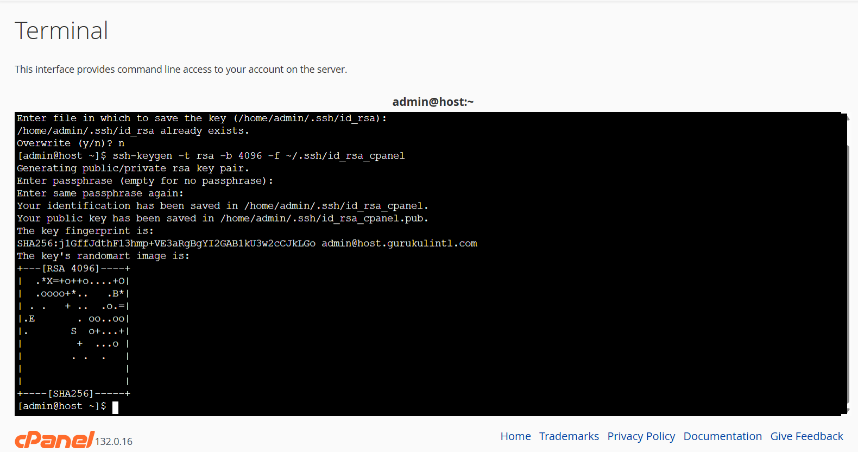

- Once SSH key is generated Goto SSH Access-> Manage SSH Keys
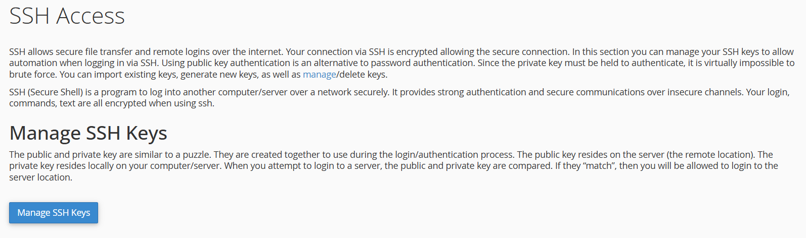
under Public keys section it will show our newly created SSH KEY
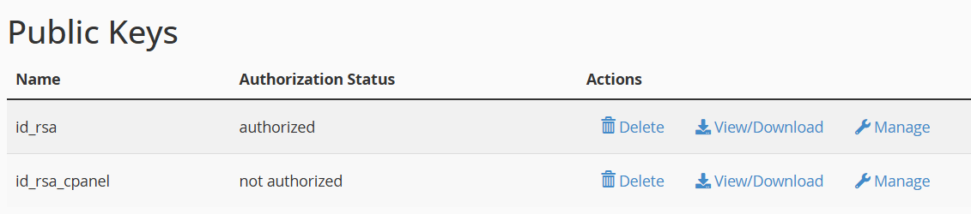
Click on Manage->Authorize
Then click on View/Download and Copy the entire SSH Key
- Go to your Github repository which you want to clone
- Settings->Deploy Keys
ii. Add Your Copied SSH Key.
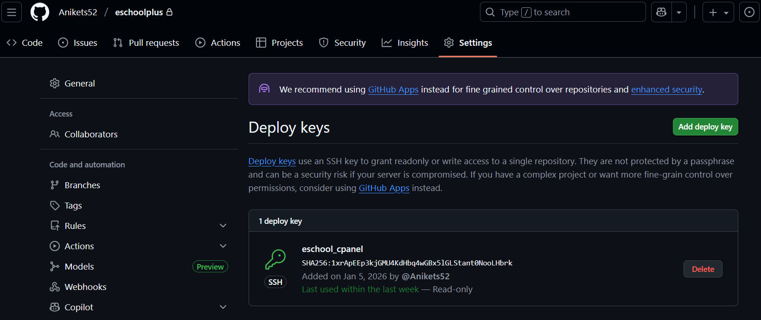

iii. To check Whether SSH Key is get correctly or not:
iv. Goto Terminal and type:
- ssh -T git@github.com

It should show output like:
Hi Anikets52/eschoolplus! You've successfully authenticated, but GitHub does not provide shell access.

- Note: In Case of Error run
ssh -vT git@github.com”
[this will give a verbose output]

- Go back to Cpanel and click on


- Click On Create :

- Clone URL: Copy the SSH link of your repo from Github and paste it here
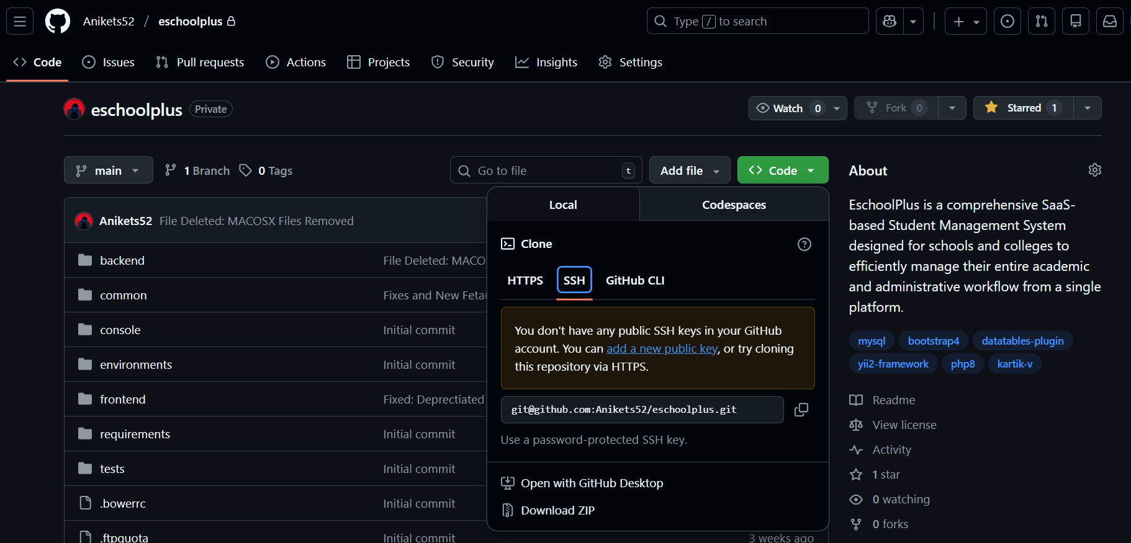

- Repository Path : select the path on the server where you want to clone the repo
- Repository Name: Can be Anything, this doesn’t matter let it be default

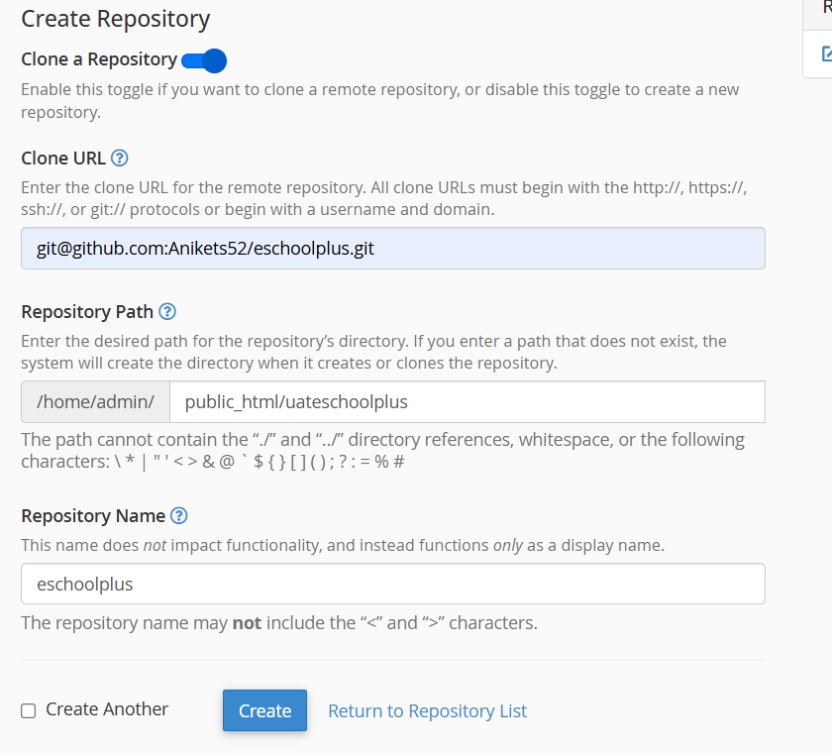
- Once Done, It will Automatically Pull the Code from Github and your repository will be listed:

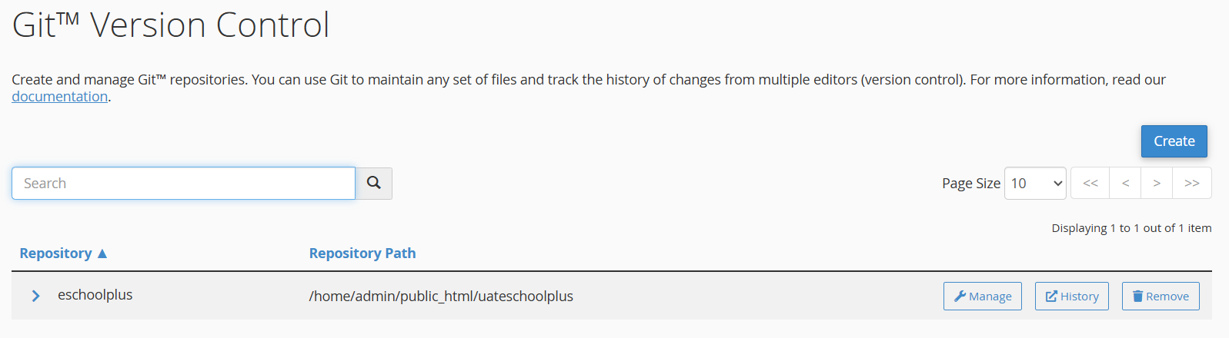
- Now To install Dependency [vendor folders] we need composer, look if “composer.phar” file is there in your repository:
If YES,
- Then check its version

- php composer.phar --version
[this will show the composer version installed]

[Change present working directory to the directory where you cloned the repo]

cd /home/admin/public_html/uateschoolplus
php composer.phar install
[this will download all the dependencies]

Note : In case of Php version mismatch occurs during “php composer.phar install”
Command then, Run this command and check the version:

- /opt/cpanel/ea-php80/root/usr/bin/php -v

//OR//
- /opt/cpanel/ea-php82/root/usr/bin/php -v

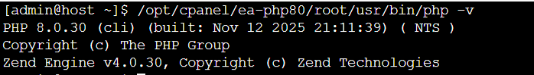

Select the Php version that is compatible with your dependencies and then run :
-
/opt/cpanel/ea-php82/root/usr/bin/php composer.phar install

[This will download all the dependencies]

If No ,
In Your Localmachine open cmd and run:

-php -r "copy('https://getcomposer.org/installer', 'composer-setup.php');"
[This created a file named ‘composer-setup.php’]
php composer-setup.php
[this created the ‘composer.phar’ that can be used to install dependencies]
- Copy this file into your Cpanel root directory and then change the PWD and run the same above commands ‘php composer.phar install’ to download the dependency
- Add a small snipet of code in .htaccess to specify the php version it should run on:

<IfModule mime_module>
AddHandler application/x-httpd-ea-php82___lsphp .php .php7 .phtml
</IfModule>
Note: Cpanel doesn’t allow creating folders and file through code so run this command to give it full permission.
mkdir backend/web/assets
chmod 775 backend/web/assets
ls -la assets //////owner should be admin

chmod -R 777 backend/runtime frontend/runtime backend/web/assets frontend/web/assets

- Auto-deploy on every git push - Set up GitHub Webhooks

Enable Deployment in cPanel
- Go to cPanel → Files → Git™ Version Control
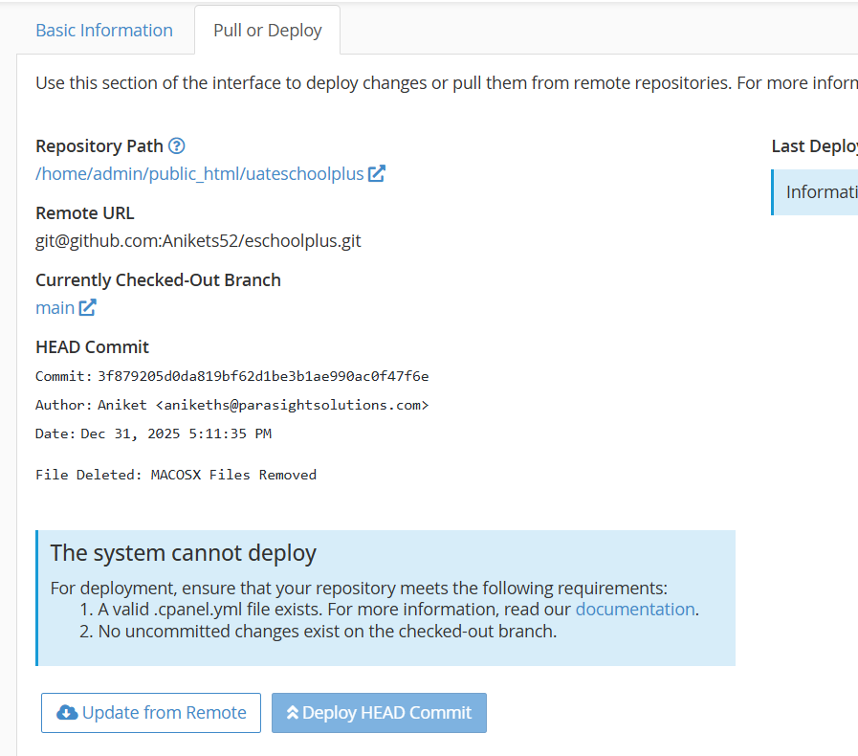
- If it says “The System Cannot Deploy” then we need to create a file named “.cpanel.yml” in repo root.
.cpanel.yml:

---
deployment:
tasks:
- export DEPLOYPATH=/home/admin/public_html/uateschoolplus
- cd $DEPLOYPATH
- git pull origin main

In cpanel terminal:
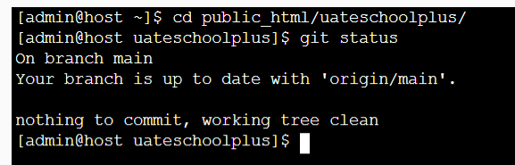
Once .cpanel.yml file is created and in cpanel terminal it shows “Working Tree Clean” then the deployment button will be shown :
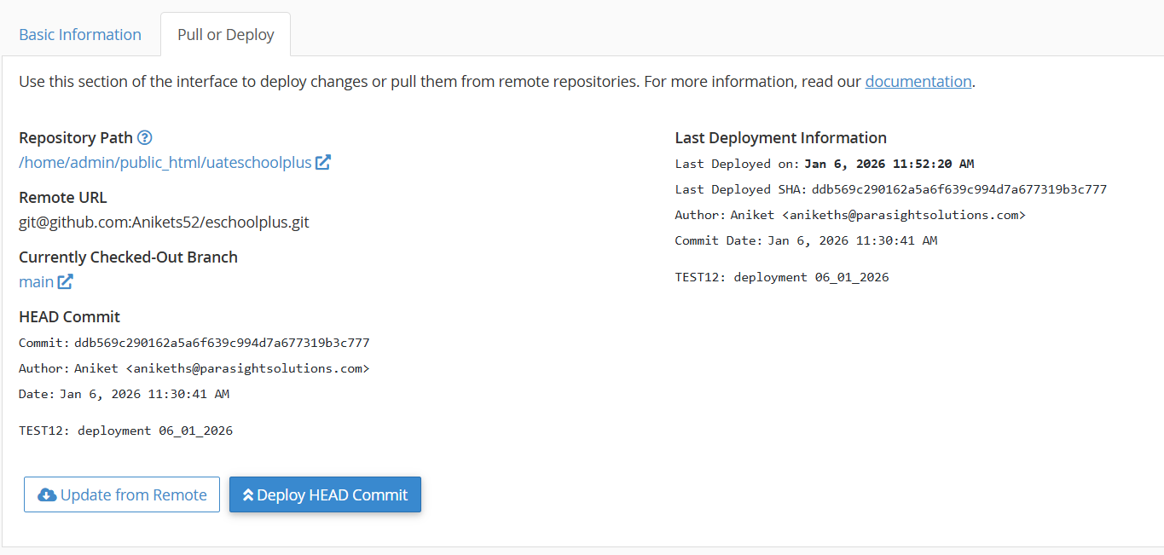
Click On “Deploy HEAD Commit” and the latest code will be pulled from github repository.

Note:
We can also do this using:
- Webhook : we need to create our own deploy.php file and then in github go to the Repo Settings->Webhooks enter the URL to deploy.php file and enter the SECRET used in deploy.php file and create
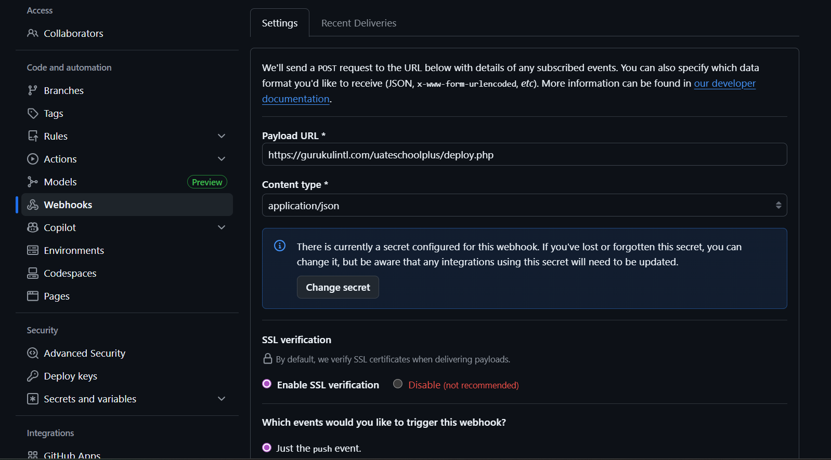
In .htaccess: [at the very top before any Rewrite Rule Paste this ]
.htaccess:
# === Allow GitHub webhook deploy script ===
RewriteCond %{REQUEST_URI} ^/uateschoolplus/deploy\.php$
RewriteRule ^ - [L]

RedirectMatch 404 /\.git

- Cron:
Create: /home/admin/deploy.sh
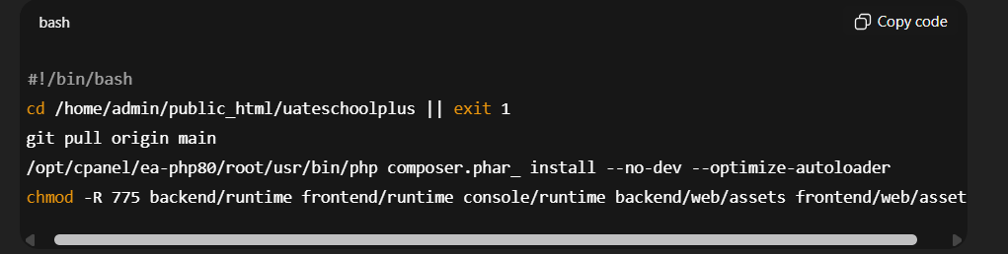
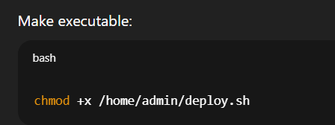
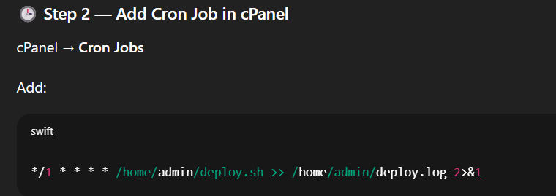

Using Multiple SSH keys, one key for each repo:

Create SSH config file (if it doesn’t exist)

nano ~/.ssh/config

Add this configuration
# eschoolplus repo
Host github-eschoolplus
HostName github.com
User git
IdentityFile ~/.ssh/id_rsa
IdentitiesOnly yes

# dnyanamudra repo
Host github-dnyanamudra
HostName github.com
User git
IdentityFile ~/.ssh/id_rsa_dmv
IdentitiesOnly yes

Save and exit (Ctrl + X, Y, Enter).

Fix permissions (important!)
chmod 600 ~/.ssh/config
chmod 600 ~/.ssh/id_rsa
chmod 600 ~/.ssh/id_rsa_dmv

How to clone each repo (this part matters)

✅ eschoolplus

git clone git@github-eschoolplus:Anikets52/eschoolplus.git

✅ dnyanamudra

git clone git@github-dnyanamudra:Anikets52/dnyanamudra.git

Do NOT use git@github.com: anymore for these repos
Always use the matching host alias.

Verify each key independently (recommended)

ssh -T git@github-eschoolplus

Should say:
Hi Anikets52/eschoolplus!

ssh -T git@github-dnyanamudra

Should say:
Hi Anikets52/dnyanamudra!

